介數中心性程式碼

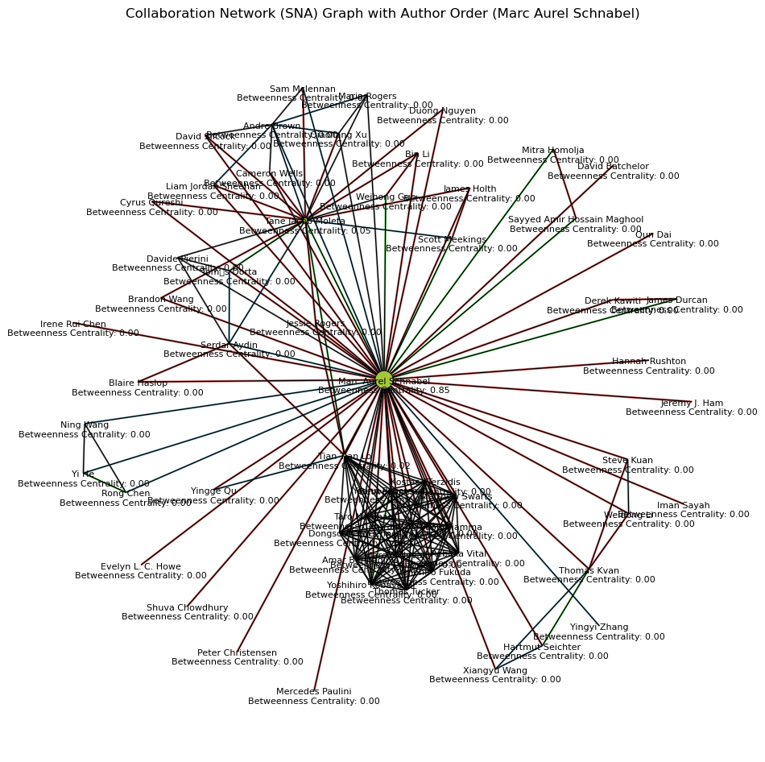

import networkx as nx

import pandas as pd

import matplotlib.pyplot as plt

# 创建一个空的无向图

G = nx.Graph()

# 从Excel文件加载数据

excel_file = "CADVis_Author.xlsx" # 替换为您的Excel文件路径

df = pd.read_excel(excel_file)

# 根据相同的 work_id 创建节点和边

for work_id, group in df.groupby("work_id"):

authors = group["Fullname"].tolist()

order = group["Order"].tolist()

# 添加节点（作者）

for author in authors:

G.add_node(author) # 添加节点（作者）

# 添加带有作者顺序的边（合作关系）

for i in range(len(authors)):

for j in range(i + 1, len(authors)):

G.add_edge(authors[i], authors[j], order=order[i]) # 使用order[i]来表示作者顺序

# 创建一个子图，只包括与Marc Aurel Schnabel相关的节点和边

subgraph = G.subgraph(["Marc Aurel Schnabel"] + list(G.neighbors("Marc Aurel Schnabel")))

# 计算节点的介数中心性

betweenness_centrality = nx.betweenness_centrality(subgraph)

# 计算节点的大小，根据介数中心性调整

node_size = [300 * betweenness_centrality[node] for node in subgraph.nodes()]

# 可视化SNA图

plt.figure(figsize=(12, 12))

# 自定义布局

pos = nx.spring_layout(subgraph, seed=42)

# 绘制边，根据作者顺序添加不同颜色的边（浅色系）

for edge in subgraph.edges(data=True):

order = edge[2]["order"]

if order == 1:

edge_color = "lightcoral" # 浅红色

elif order == 2:

edge_color = "lightblue" # 浅蓝色

elif order == 3:

edge_color = "lightgreen" # 浅绿色

else:

edge_color = "lightgray" # 浅灰色

nx.draw_networkx_edges(subgraph, pos, edgelist=[(edge[0], edge[1])], edge_color=edge_color, width=2)

# 绘制节点，节点大小基于介数中心性，节点颜色为芥末色

nx.draw(subgraph, pos, node_size=node_size, node_color='#A4C639', with_labels=False, edgecolors='black', linewidths=0.5)

# 绘制节点标签（介数中心性），但调整它们的位置以避免重叠，并设置文字颜色为深黑色

label_pos = {k: (v[0], v[1] - 0.02) for k, v in pos.items()}

labels = {node: f"{node}\nBetweenness Centrality: {betweenness_centrality[node]:.2f}" for node in subgraph.nodes()}

nx.draw_networkx_labels(subgraph, label_pos, labels=labels, font_size=8, font_color='#000000')

plt.title("Collaboration Network (SNA) Graph with Author Order (Marc Aurel Schnabel)")

plt.axis('off') # 关闭坐标轴

plt.show()

**轉成JSON檔**

import networkx as nx

import pandas as pd

import json

# 创建一个空的无向图

G = nx.Graph()

# 从Excel文件加载数据

excel_file = "CADVis_Author.xlsx" # 替换为您的Excel文件路径

df = pd.read_excel(excel_file)

# 根据相同的 work_id 创建节点和边

for work_id, group in df.groupby("work_id"):

authors = group["Fullname"].tolist()

order = group["Order"].tolist()

# 添加节点（作者）

for author in authors:

G.add_node(author) # 添加节点（作者）

# 添加带有作者顺序的边（合作关系）

for i in range(len(authors)):

for j in range(i + 1, len(authors)):

G.add_edge(authors[i], authors[j], order=order[i]) # 使用order[i]来表示作者顺序

# 创建一个子图，只包括与Marc Aurel Schnabel相关的节点和边

subgraph = G.subgraph(["Marc Aurel Schnabel"] + list(G.neighbors("Marc Aurel Schnabel")))

# 计算节点的介数中心性

betweenness_centrality = nx.betweenness_centrality(subgraph)

# Create a dictionary to store the graph data

graph_data = {

"nodes": [],

"links": []

}

# Add nodes to the dictionary

for node in subgraph.nodes():

graph_data["nodes"].append({

"id": node,

"betweenness_centrality": betweenness_centrality[node]

})

# Add links to the dictionary

for edge in subgraph.edges(data=True):

order = edge[2]["order"]

graph_data["links"].append({

"source": edge[0],

"target": edge[1],

"order": order

})

# Save the JSON data to a file

json_file = "graph_data.json"

with open(json_file, "w") as f:

json.dump(graph_data, f, indent=4)

print(f"Graph data has been saved to {json_file}")

**轉成JSON檔**

import networkx as nx

import pandas as pd

import matplotlib.pyplot as plt

import json

from networkx.readwrite import json_graph

# Create an empty undirected graph

G = nx.Graph()

# Load data from the Excel file

excel_file = "CADVis_Author.xlsx" # Replace with your Excel file path

df = pd.read_excel(excel_file)

# Create nodes and edges based on the 'work_id'

for work_id, group in df.groupby("work_id"):

authors = group["Fullname"].tolist()

order = group["Order"].tolist()

for author in authors:

G.add_node(author)

for i in range(len(authors)):

for j in range(i + 1, len(authors)):

G.add_edge(authors[i], authors[j], order=order[i])

# Create a subgraph with Marc Aurel Schnabel and related nodes

subgraph = G.subgraph(["Marc Aurel Schnabel"] + list(G.neighbors("Marc Aurel Schnabel")))

# Calculate node degree centrality

degree_centrality = nx.degree_centrality(subgraph)

# Calculate node sizes based on degree centrality

node_size = [300 * degree_centrality[node] for node in subgraph.nodes()]

# Visualize the graph

plt.figure(figsize=(12, 12))

pos = nx.spring_layout(subgraph, seed=42)

for edge in subgraph.edges(data=True):

order = edge[2]["order"]

if order == 1:

edge_color = "lightcoral"

elif order == 2:

edge_color = "lightblue"

elif order == 3:

edge_color = "lightgreen"

else:

edge_color = "lightgray"

nx.draw_networkx_edges(subgraph, pos, edgelist=[(edge[0], edge[1])], edge_color=edge_color, width=2)

nx.draw(subgraph, pos, node_size=node_size, node_color='#A4C639', with_labels=False, edgecolors='black', linewidths=0.5)

label_pos = {k: (v[0], v[1] - 0.02) for k, v in pos.items()}

labels = {node: f"{node}\nDegree Centrality: {degree_centrality[node]:.2f}" for node in subgraph.nodes()}

nx.draw_networkx_labels(subgraph, label_pos, labels=labels, font_size=8, font_color='#000000')

plt.title("Collaboration Network (SNA) Graph with Author Order (Marc Aurel Schnabel)")

plt.axis('off')

plt.show()

# Export graph structure to JSON

graph_data = json_graph.node_link_data(subgraph)

with open('graph_data.json', 'w') as json_file:

json.dump(graph_data, json_file, indent=2)

# Export node attributes (degree centrality) to JSON

node_attributes = {node: degree_centrality[node] for node in subgraph.nodes()}

with open('node_attributes.json', 'w') as json_file:

json.dump(node_attributes, json_file, indent=2)